Chapter 4 Fission and Fusion
Chapter Test Total marks 45

Name: Class: Date:
Use the following values in your calculations:
Charge on an electron: Q = –1.60 × 10–19 C
Speed of light: c = 3.0 × 108 m s–1
Questions
Question 1
For the following radioisotopes, calculate the number of:
i protons ii neutrons ii nucleons:
a. (3 marks)

b. (3 marks)

Question 2
a. Balance the following equation by replacing A and Z. (2 marks)

b. How does the combined mass of the products compare with the mass of the U-238 nucleus? (1 mark)

Question 3
To produce fusion, which of the following must be overcome? (1 mark)
- the strong nuclear force
- the electrostatic force
- the binding force
- the weak nuclear force

Question 4
Which of the following is responsible for holding the nucleus of an atom together? (1 mark)
- strong nuclear force
- weak nuclear force
- binding force
- electrostatic force
- gravity

Question 5
Consider the fission reaction below:

a. Determine the identity of the missing item X. (2 marks)

b. Convert the energy released into joules. (1 mark)

c. How much mass was converted to energy in the reaction? (2 marks)

d. Using the fact that 1.00 kg of uranium-235 contains 2.5 × 10²⁴ nuclei, how much energy would be released if all the nuclei in 1.00 kg of uranium-235 underwent fission? (2 marks)

Question 6
The following is a diagram of a thermal nuclear power station.
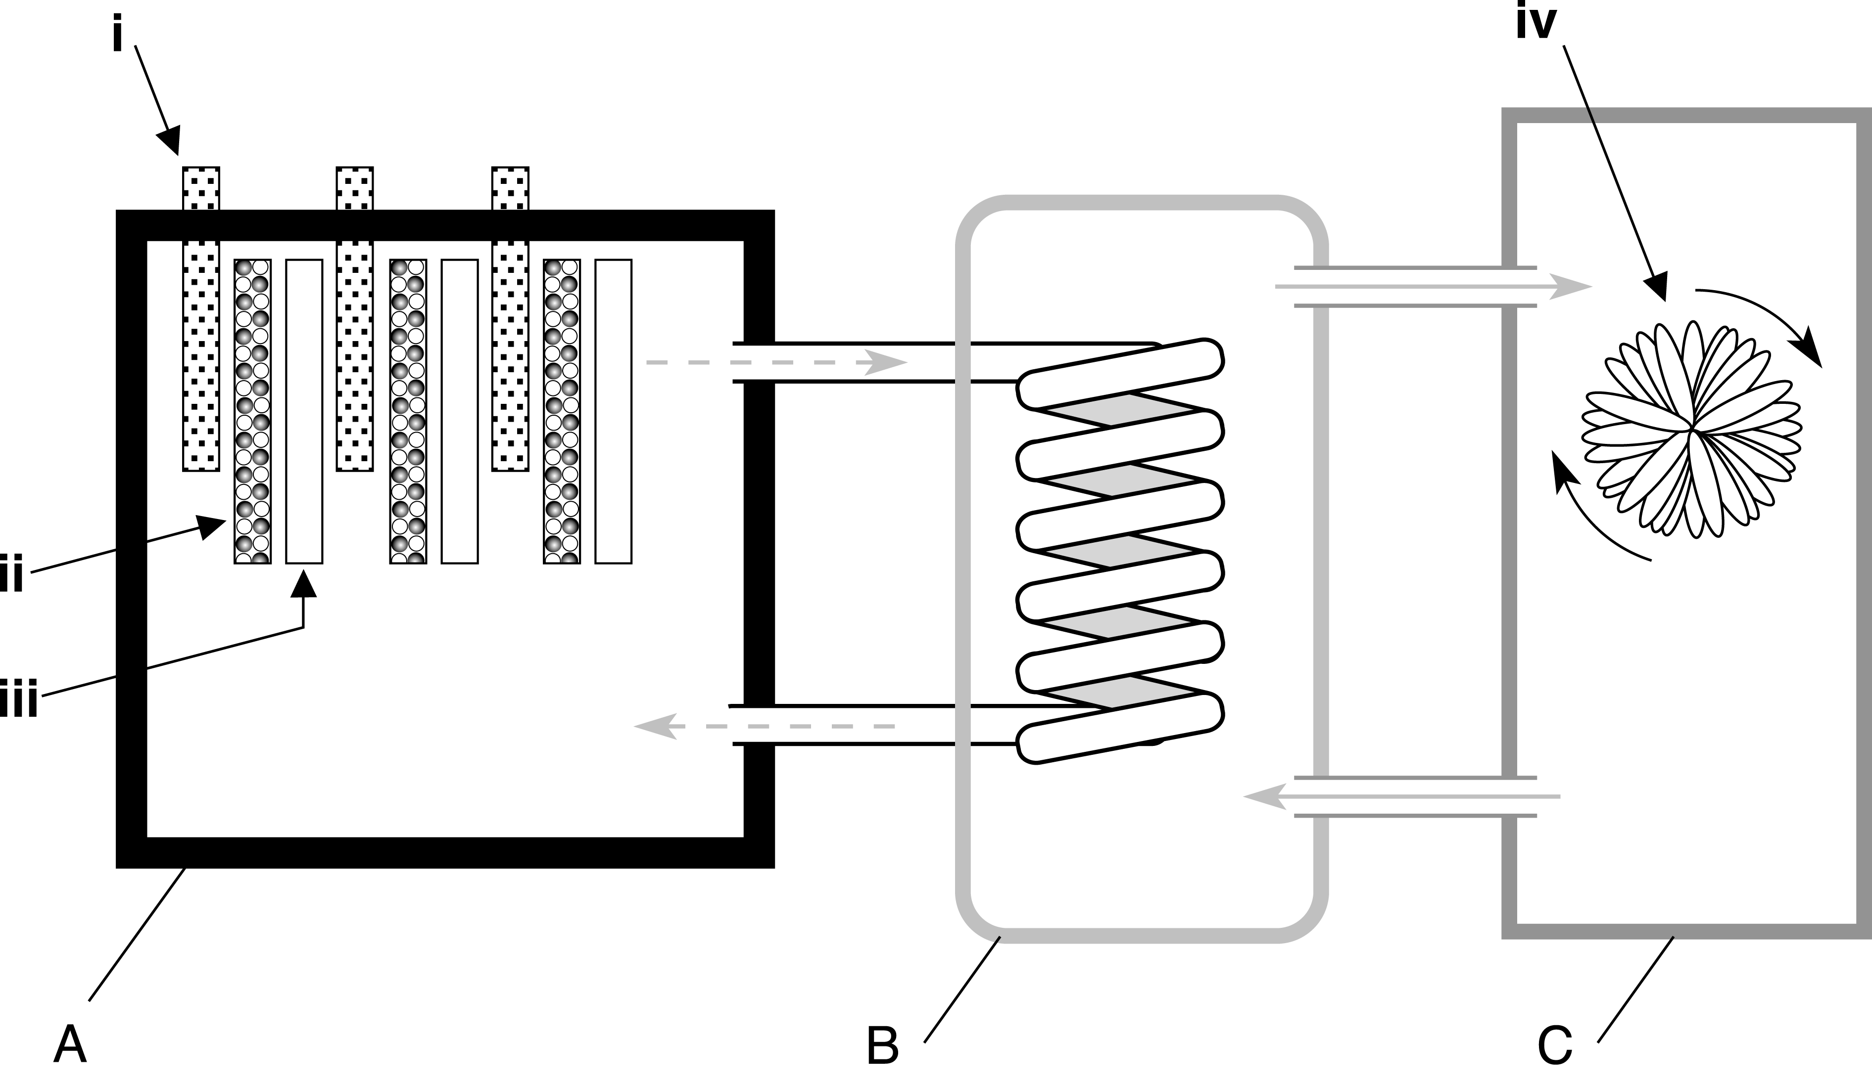

a. Name the parts labelled i, ii, iii and iv. (4 marks)

b. Name and describe the function of the sections labelled A, B and C. (6 marks)

Question 7
Explain why a chain reaction does not occur in the uranium ore that is dug up from a uranium mine. (2 marks)

Question 8
State the main environmental concerns associated with coal-fired power stations and nuclear power stations. (2 marks)

Question 9
A particular nuclear reactor generates about 1200 MW of electrical power, but operates at about 25% efficiency; i.e. only 25% of the thermal energy is transformed into electrical energy.

a. How much electrical energy is generated each day? (2 marks)

b. Assuming that this energy has been transformed from uranium-235, how much uranium-235 (in grams) is consumed each day by this plant? (2 marks)

c. How much energy is converted into electrical energy? (1 mark)

Question 10
One of the reactions taking place in a fusion reactor is shown below:
a. How many neutrons are released during this fusion reaction? (1 mark)

b. How does the combined mass of the reactants compare with the combined mass of the products in this fusion reaction? (2 marks)

c. About 15 MeV of energy is released during this fusion reaction. How much energy is this in joules? (2 marks)

Question 11
One of the fusion reactions taking place inside the Sun is shown below:
a. Identify the missing nuclide X. (2 marks)

b. If 4.0×10⁻¹² J of energy is released during this fusion reaction, how much is released in electronvolts? (1 mark)

